|  |  |
| --- | --- |
| PROG 3B task 2  Documentation | Application: Dewey Training  Application ID: DT1.19  Version: 1.19  Student Name: Karl Dicks  Student Number: 17667327  Course: BCAD3  Subject: PROG7312  Lecturer: Nirasha Ramckurran  Assignment: Task 2  Due Date: 13/10/2020 |

Contents

Introduction 2

Help File 4

Readme 8

Screenshots 12

Database Entities 26

Use Case Diagram 27

Conclusion 28

References 29

# Introduction

As part of our PROG7312 (3B) module, we were tasked with developing a Dewey Decimal training application. I chose to develop the application in C#, using the Visual Studio 2019 IDE, as we were familiar with this IDE from other programming modules. My application has been built in Windows Presentation Foundation (WPF) in .Net Core 3.1. There were a number of requirements that the application had to perform, which have been implemented in my Task 1 and 2, and this will be expanded on for the POE project, in accordance with our set question paper. (The Independent Institute of Education, 2020)

The training application allows users to perform multiple actions, including:

* **Register and login**  
  The training application allows the user to register an account with their own preferences, and log in. User profiles are stored in a local MSSQL MDF file, along with their scores used by the application. This database can easily be migrated to an online Azure database, so that high scores are accessible by everyone in the library or elsewhere.
* **Replace Books**The application will allow users to order randomly generated Dewey Decimal Call Numbers (10) – including the decimals and authors into the correct order.  
  Once the user correctly orders the call numbers, by dragging the books to their correct order, the user will be automatically navigated to a confirmation page.
* **Gamification Techniques**A number of gamification techniques have been implemented, including all those described in the research document.  
  These include:
  + **Leaderboards**The user will be able to see the top ten scores (game completion times), as these are saved for signed-in users and stored in the database file. These scores are then retrieved and displayed on the home screen when the user first loads the application. (Quicksprout, 2016)
  + **Challenges**The application has implemented a timer, and difficulty levels. For example, the user can set the difficulty to “Easy” which allows the user 60 seconds to complete the ordering / test process. They can set it to “Medium” for 40 seconds, and “Hard” for 30 seconds. This provides different levels of difficulty for the user to complete the ordering in set timeframes. (Quicksprout, 2016)
  + **Feedback**The application displays a timer, and once the timer reaches 10 seconds, it will start to alternate between red and white text color, to indicate that the time is almost finished for the user to complete the ordering. (Laja, n.d.)
  + **Rewards**The application shows the top ten scores on the home screen, and these scores are for logged in users only, as the score is linked to their user account. Anonymous users can still use the application without logging in, and will receive their time, however it will not be logged and displayed on the home screen.  
    The top three scores will have different colours, much like a podium system, where the top scorer gets their row in gold, second in silver, and third in bronze. (Laja, n.d.)
  + **Progress**In addition to the above gamification techniques, the user will be able to view all their personal scores on a grid view, and this will be displayed by highest score first (lowest time taken to complete the ordering). This allows the user to track their progress over time, if they are logged in. (Quicksprout, 2016)
* **Restart Training**Finally, the user will be able to restart their game by pressing the “Restart” button on the “Replace Books” page. This will reset the timer, replace the books with new auto-generated call numbers and authors, and allow them to start the game again. (The Independent Institute of Education, 2020)

# Help File

The training application provides numerous functions, which will be described in depth in the following section. The help file has been broken up into multiple sections, describing each page of the desktop application.

**Home Page**The application will first load to the home page, as an “Anonymous User”. An anonymous user can view all high scores, set difficulty of the game, login, register, and access the “Replace Books” function required for Task 1.

* The high scores will be displayed in a data grid on the right-hand side of the home screen, with scores (time taken to complete the ordering of the books, or categorize the books), usernames, and the date and time that the user took the test.
* The user can access the “Replace Books”, “Identify Areas”, or “Find Call Numbers” functions, however they will not be able to save their high scores or access their score log without signing in. Therefore, their high score will not be displayed on the home screen.
* In addition to this, the top three scores are displayed with different background colours, in order to create a podium-like system. For example, the highest score will be displayed with a gold background, second highest will be displayed with a silver background, and the third will be displayed with a bronze background.
* The user may use button click events to complete the following actions:
  + Navigate to the login / registration page,
  + Navigate to the replace books page,
  + Navigate to the identify areas page,
  + Navigate to the view all scores page,
  + Exit the training application,
  + Minimize the window.
* Once the user has logged in, and is no longer an anonymous user, they may select a “View All Scores” button on the home screen, which will display their score log on a data grid.
* The user may select the different score views by selecting the “Set Score View” combo box and choosing a test type.
* The user may also set the game difficulty by selecting the combo box at the bottom of the main page, and from there they can select either “Easy”, “Medium”, or “Hard”, which will set the time limit for the various games.

The login functionality will be described next.

**Login Page**  
Once the user selects the “Login” button on the home screen, they will be brought to a page where they can log into an existing account, or register a new account on the system.

The login page provides a number of buttons, and input, including:

* Username input,
* Password input,
* Register button – brings the user to a registration page,
* Login button – logs the user in,
* Back button (left arrow at the top left of the screen).

The user can enter their unique credentials, and log into their account. The logged in username at the top left of the screen will be changed to “User: <username>”, e.g. “User: Karl”.

Once the user has logged in successfully, they will be brought back to the home page, where they can navigate to all functionality of the application.

The login page validates user accounts, and therefore if the user credentials are incorrect, they will not be logged in, and a generic “Username / Password Incorrect” message will be displayed.  
This is a generic message, as to not encourage username harvesting, whereby users attempt to determine valid usernames, if only the password is incorrect – e.g. the message does not display “Password Incorrect”, when a username is in fact valid, however a password is incorrect.

**Register Page**The user can navigate to the register page, once they press the “Register” button on the login page. This page allows new users to sign up an account with the system.

A number of buttons and input boxes are displayed on the register page, including:

* Username input,
* Password input,
* Confirm password input,
* Register Account button,
* Back button (left arrow at the top left of the screen).

The user can enter unique credentials on this page, and create a new account with the system. If the user enters a username already in use, an error message will be displayed, and password validation ensures both the confirm password and password input boxes contain the same password values.

Once the user enters valid credentials, they can press the “Register Account” button, which will create the account in the database, and navigate the user back to the login page, where they can login with their new details.

**Replace Books**This page provides functionality required for replacing books, where the user can:

* View auto-generated Dewey Decimal Call Numbers, which are shown on a data grid on the right of the page. These Dewey Decimal’s show the decimal as well as the author.  
  Both of these values (decimal, and author) are automatically generated using a custom random generator.
* Re-order the books into their correct order, as the application randomly places books on the “shelf”, for example, the Dewey Decimal system requires that all books are ordered by numerical order as well as alphabetically – e.g. “035.8605 NVG” comes before “035.8605 ZAK” or “035.8605 NVG” comes before “125.8605 ABC”.  
  The user can simply drag and drop rows (books) into the correct order on the “shelf”, once they press the “Start” button.
* Start the game by pressing the “Start” button on the bottom left of the page. Once started, the timer will start to tick down to show the time remaining. The difficulty setting will determine how long the user has to correctly order the books.  
  In addition to this, the Call Numbers will be generated again, so users cannot determine where the books should be before starting the game, and have the timer tick down.
* The user may return to the main page by pressing the “Return” button. This will cancel the current training session or “game”. This score will not be logged, and the user will have to restart the game to start again.

Once the user re-orders all books, they will be navigated to a confirmation page, where they can view time taken to order the books (score in seconds). If they are logged in, this score will be saved in the database, along with the logged in user and time taken of the test.

**Replace Books Confirmation Page**Once the books have been ordered, or the time has run out, the user will be navigated to a confirmation page, which will either display “The books have been successfully ordered” or “The books have not been successfully ordered”.  
When the user orders the books in the correct order within the specified timeframe (e.g. 30 seconds), the time taken to complete the ordering of the books will be displayed.

In addition to showing this information, the following actions can be completed on this page:

* Finish – navigates the user back to the home page.
* View Order – navigates the user to a page where the correct order of the books is displayed, according to the Dewey Decimal System – in numerical and alphabetical order.

**Identify Areas**This page provides functionality required for identifying areas, where the user can:

* View match the column questions, which have top level (category) call numbers and their descriptions in two list boxes. One list box has the questions, which can contain both descriptions or top-level call numbers. There are 4 questions, and 7 possible answers (4 of which are correct), and are displayed in the second list box.
* The user may start the game, which will allow them to select items from the drop-down lists. Once the user presses the “Start” button, they can select a possible answer from the right-hand column by selecting the letter associated with the answer (e.g. A. General Knowledge). The questions and answers will be automatically shuffled once the user starts a new game, however there will be 4 correct answers to the questions within the second list box.
* Once all answers have been selected from the drop-down lists, the user may proceed to click “Next”, which will check their answers against the model answer. It will navigate the user to a confirmation page that will show the time taken to complete the test, how many questions were correctly answered, and also whether the test was completed successfully (whether all answers were correct). This information will be stored in a database, which is shown on the leaderboard.
* The user can continue to play another game, with another set of questions and randomly generated answers (with 4 being correct), view the model answer, or finish the game. On the confirmation page their score will be presented, along with the time taken to complete the test.

Once the user correctly assigns the descriptions to the categories or vice versa, they will be navigated to the confirmation page described above. If they are logged in, this score will be saved in the database, along with the logged in user, score, and time taken of the test.

**Identify Areas Confirmation Page**Once the descriptions have been categorized, or the time has run out, the user will be navigated to a confirmation page, which will either display a successful message or unsuccessful message.

In addition to showing this information, the following actions can be completed on this page:

* Finish – navigates the user back to the home page.
* View Answers – navigates the user to a page where the correct answers can be viewed. If the user has not categorized the top-level call numbers correctly, they can then view this model answer after the test has been completed.
* Next – Navigates the user to a new test, so they can continue to play the game until such time as they press the “Finish” button.

# Readme

Project Title: Dewey Training

Welcome to Dewey Training. This new desktop application has been developed for librarians and other users to learn the Dewey Decimal ordering system. The aim of this application is to get librarians and other users of the system to order and manage books efficiently at libraries. This would improve efficiency, and accuracy of these users, when they replace books on the numerous shelves in a library. In addition to this, the categories of these books can be learnt by taking “Identifying Areas” tests on the application.

This application encourages users to improve their book replacement and categorization efficiency, and by extension the learning of the Dewey Decimal system. By implementing gamification techniques, such as leaderboards, challenges, feedback, rewards, and progress, the user is encouraged to compete with one another, and learn in the process. By tracking and displaying this information, the user is more likely to see the training software as a game, and therefore compete with one another.

In addition to this, the database will eventually be deployed to an online hosting platform (e.g. Azure SQL database), so that users on different devices may be able to compete with one another – they will be able to see one single leaderboard across multiple devices.

Getting Started  
The following steps are required to get the Dewey Training software running on the development environment:

* Open the application source code in Visual Studio
* Set the start-up project to “Dewey Training”
* Run the application on any Windows PC
* Ensure the system is using the dot “.” Delimiter for decimals (EN-US)

Prerequisites  
There are a few prerequisites required to run the application, including:

* Install the *latest Visual Studio
* Install prerequisites to run .Net Core 3.1 WPF desktop applications

*latest Visual Studio as of when the application was developed is: Visual Studio 2019

More detailed specifications are included below

-----------------------------------------------------------------------------  
Microsoft Visual Studio Enterprise 2019  
Version 16.7.2  
VisualStudio.16.Release/16.7.2+30413.136  
Microsoft .NET Framework  
Version 4.8.04084  
-----------------------------------------------------------------------------

Installing

* Open the application source code in Visual Studio
* Set the start-up project to “Dewey Training”
* Run the application on any Windows PC

The development test system has been detailed on the following page.

Test System  
Development PC

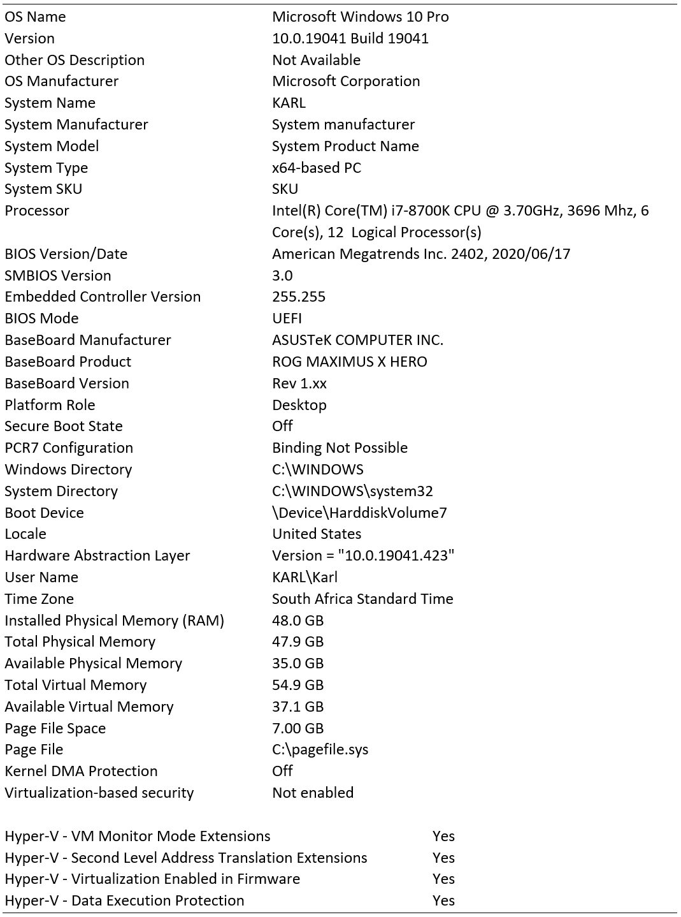

Built With  
Visual Studio – The IDE used to develop the desktop application  
.NET Core 3.1 – Framework  
WPF – Windows Presentation Foundation – Used to design the application in C# and XAML  
Models – Used to structure data within the application.  
Data Access Layer (DAL) – Assembly used to access the database.

Versioning  
---------------------------------  
Version 19  
---------------------------------

Authors Karl Dicks – 17667327  
Acknowledgments Inspiration: Programming 3B POE Question Paper  
Demo Video link: <https://youtu.be/LSJ31PAsVko>

# Screenshots

The user interface for Dewey Training desktop application has been designed, and all functionality has been implemented. Below is the interface for my application:

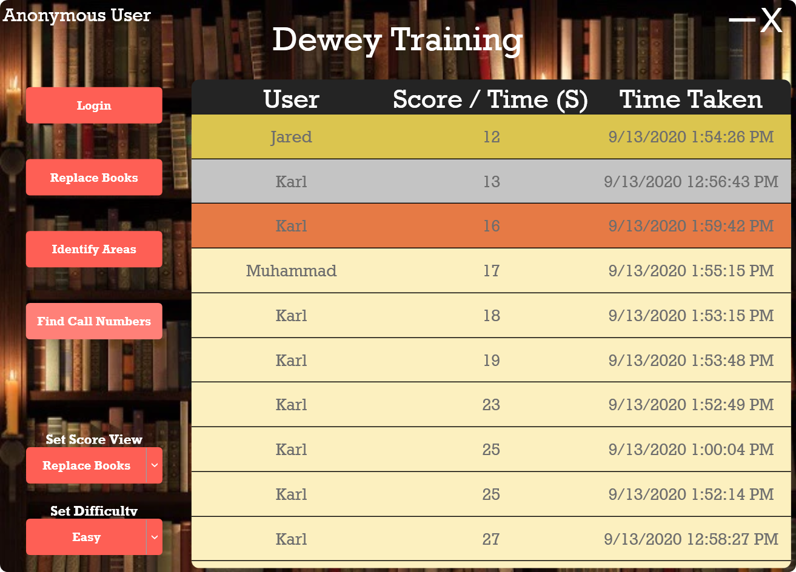**Home Page**  
Once the user loads the application for the first time, they will be presented with the home screen, and will not be logged in.

The user can navigate to the login page, or complete training “games” anonymously, which will not save their scores to the database.

If the user would like to log in, and save their scores to the database, they can log into their account by pressing the “Login” button.

This action will bring them to the page provided on the following page.

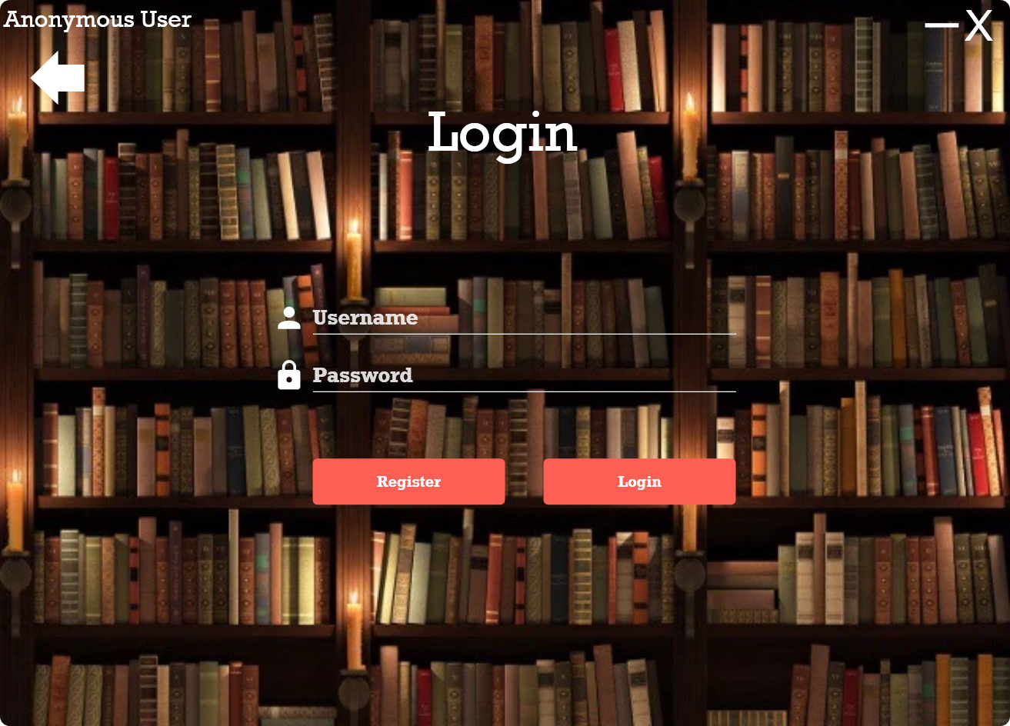**Login**

Once the user navigates to the login page, they can either log in with their previously created account, or register a new account by pressing the “Register” button.

Once the user registers a new account, they are brought back to the login page, and can enter their account details.

Once the user has pressed login, and the account is valid, they are brought back to the home page.

The register page is shown on the following page.

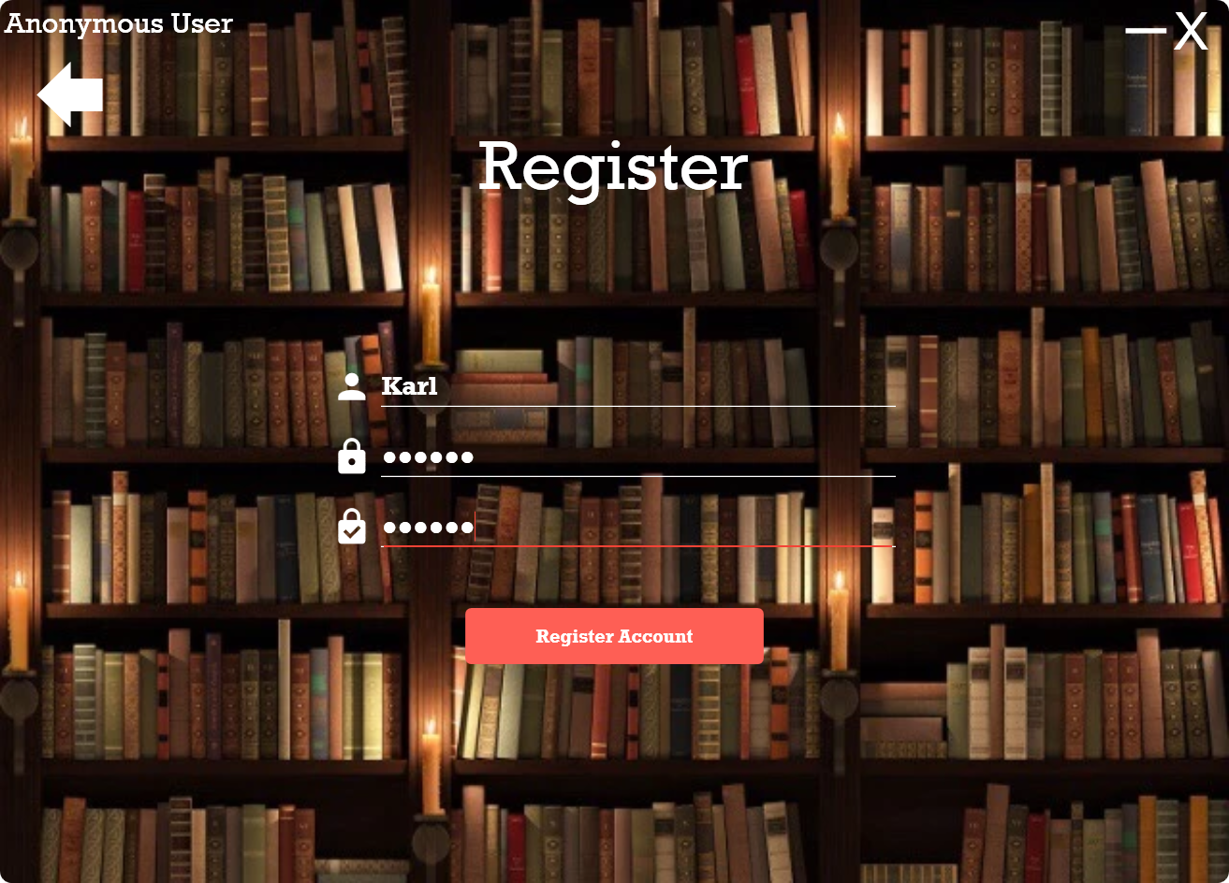**Register**

Once the user navigates to the register page, they can enter their account details, and press the “Register Account” button to create a new account on the system.

Once the user registers a new account, they are brought back to the login page, and can enter their account details.

The register page has input validation, so the passwords must match, and the username cannot be in use by another account.

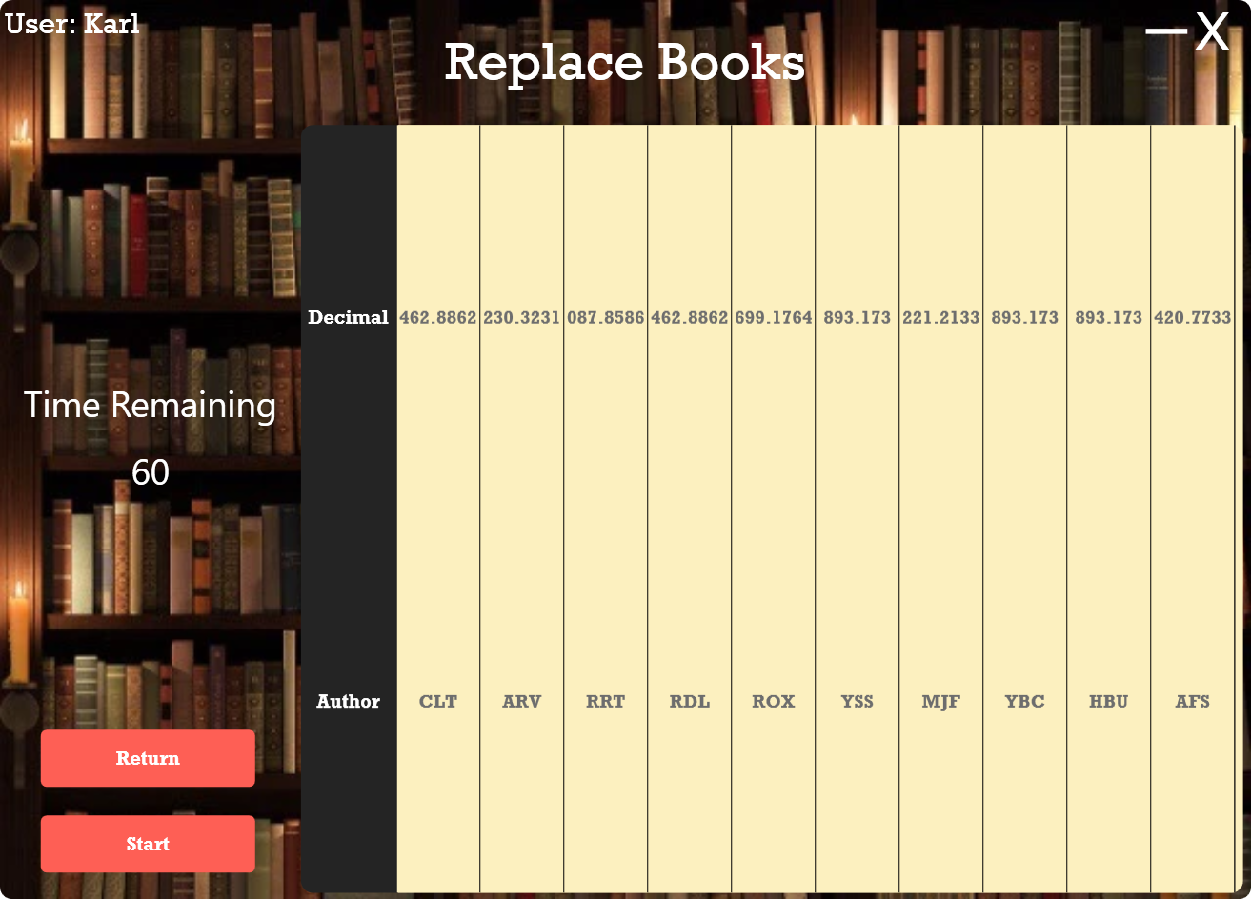**Replace Books**

The “Replace Books” page can be accessed by pressing the “Replace Books” button on the main menu, which opens a new “game” or training session.

The replace books training session works by getting users to re-order the randomly generated call numbers, in numeric and alphabetic order – just like the Dewey Decimal system describes.

Once the user is ready to start the training session, they can press the “Start” button, which will refresh the call numbers and enable dragging of the Dewey decimals on the data grid.

Once the order is correct, the user will immediately be navigated to a confirmation page, where they can view the model answer, or return to the main menu.

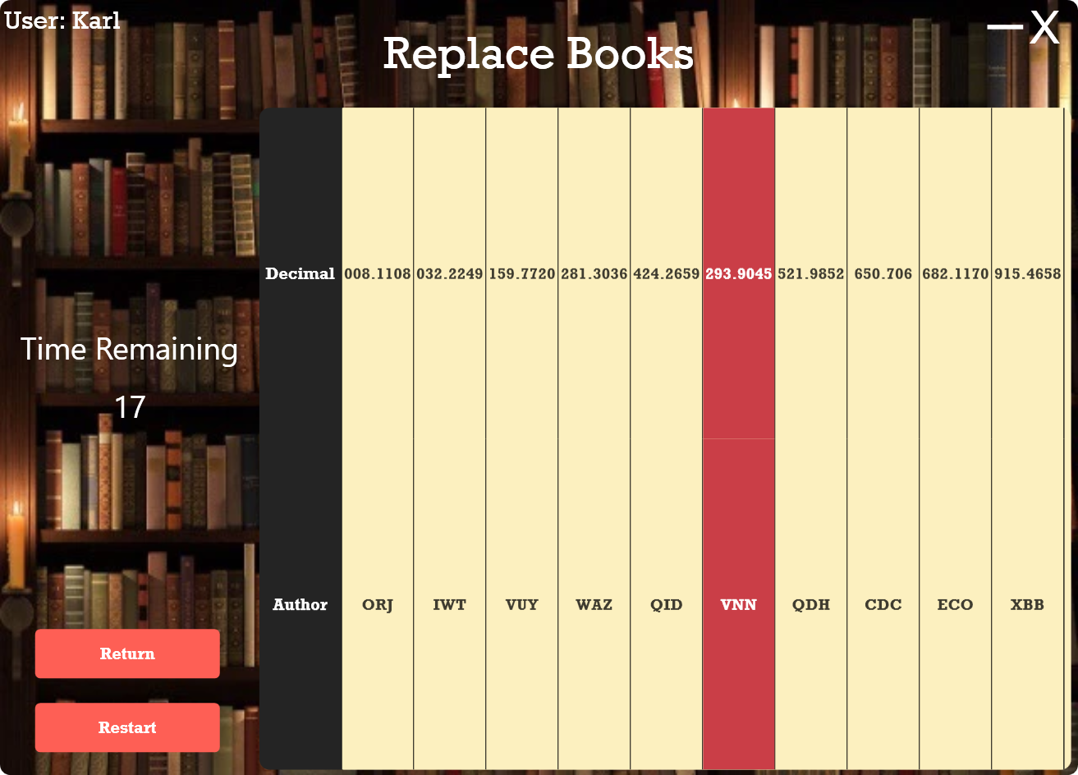**Replace Books**

The user may re-order the books by dragging them across the page (clicking, holding, and moving them), which will allow the books to be re-ordered.

As can be seen on the provided image, the books have been partially ordered, and the timer is ticking down from 60 seconds, as the difficulty level has been set to “Easy” on the home page.

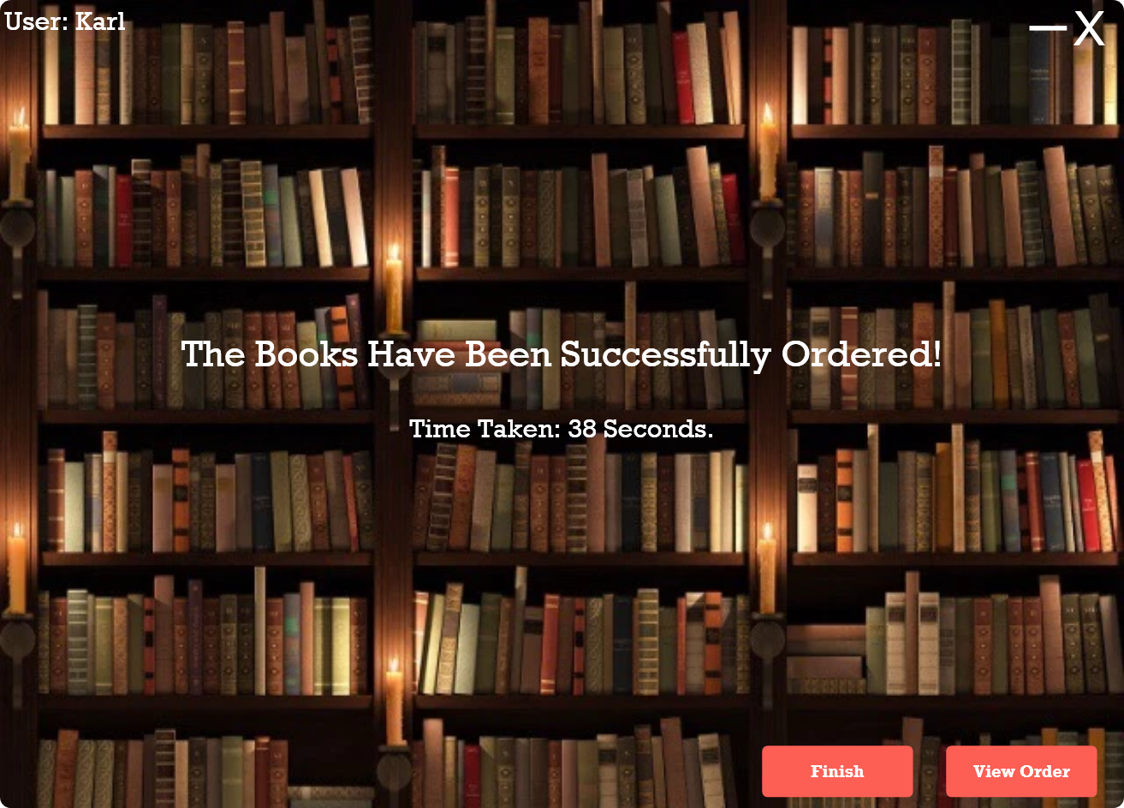**Confirmation Page**

As soon as the correct order has been reached (once the call numbers are in their correct order), the user will be navigated to a confirmation page.

Firstly, this page will show whether the user has successfully ordered the books, with a confirmation message, and the time it took them to complete the session.

This confirmation page also provides the user with the ability to “View Order”, which allows them to access the model answer for the training session. Users can press the “View Order” to view this page.

It also allows them to return to the main menu by pressing the “Finish” button.

The “View Order” model answer page is shown on the following page.

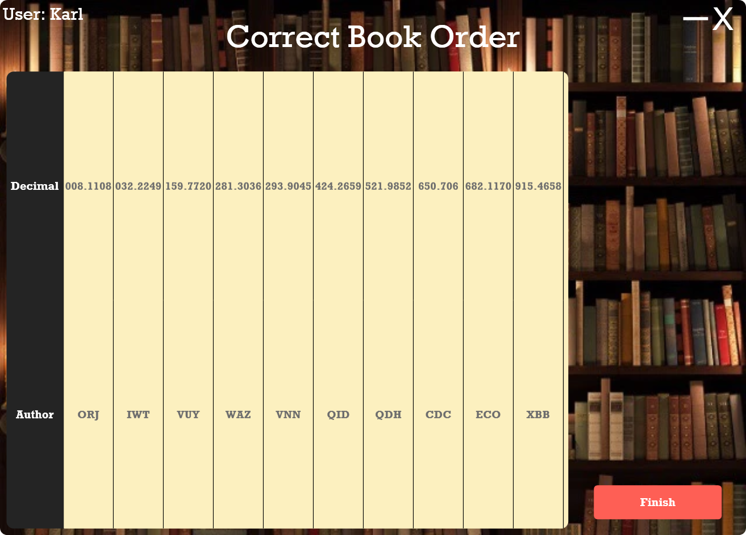**Correct Book Order**

The “View Order” page is provided on the left, which shows the correct order of the Dewey decimal call numbers.

The user may press the “Finish” button to navigate back to the main menu after they have viewed the correct order for the call numbers.

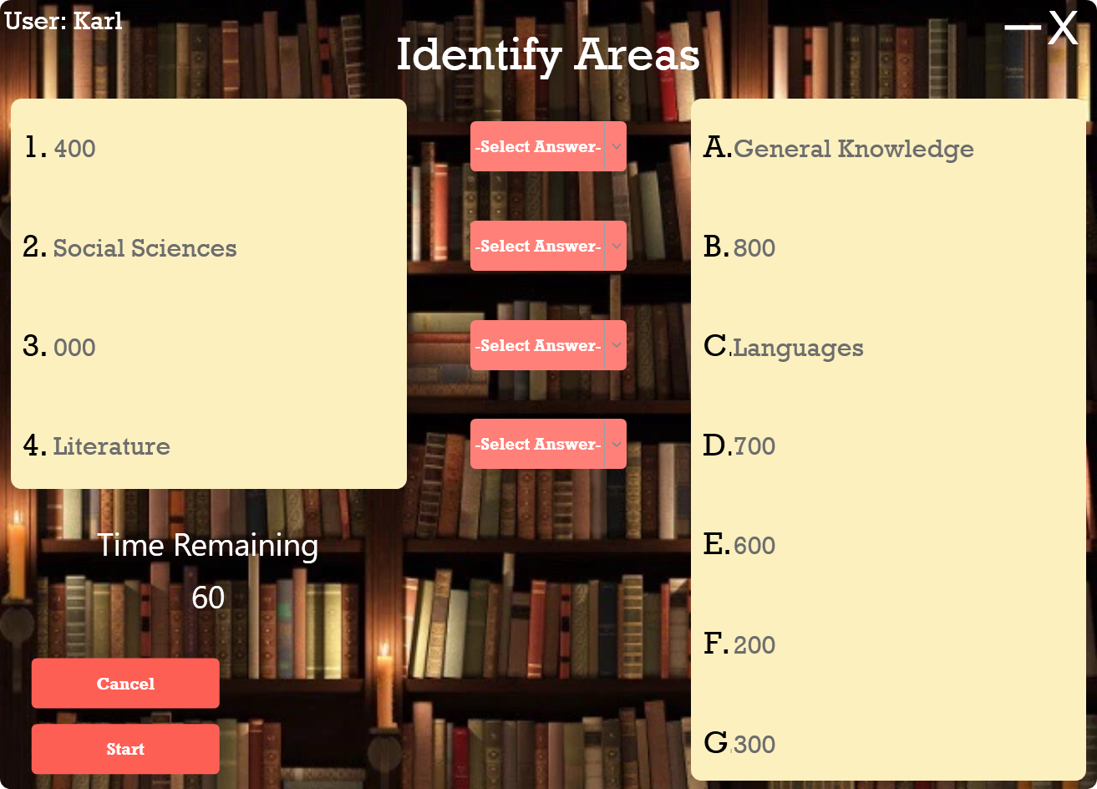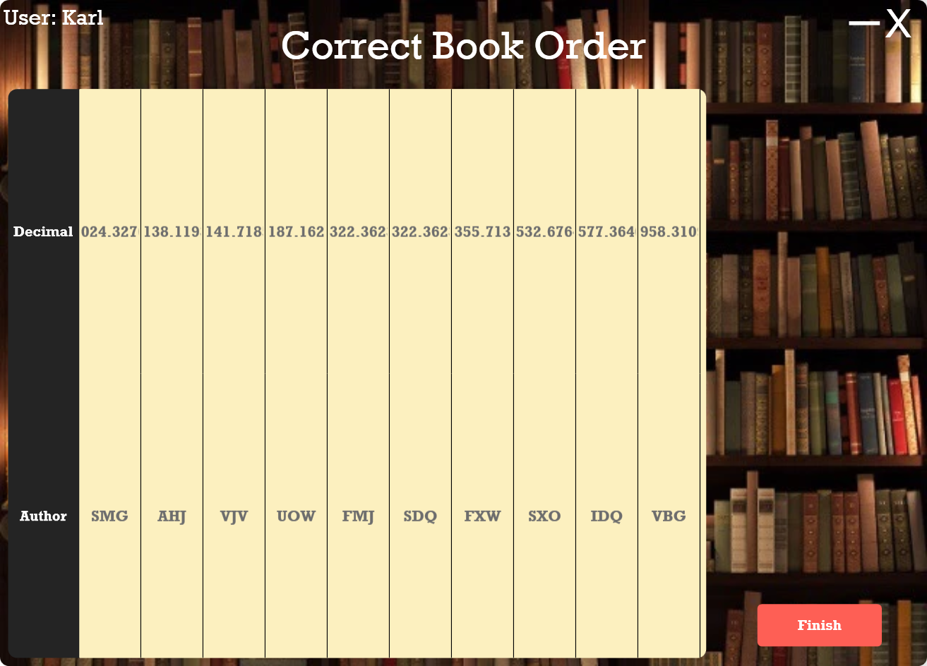**Identify Areas**

The identification of areas can be accessed by pressing the “Identify Areas” button on the main menu, which will navigate the user to the provided page.

This match-the-column training exercise provides the user with 4 randomly picked categories within the Dewey decimal system, and 7 potential answers on the right-hand side.

The user can press “Start”, which will randomize the questions and answers again, and will allow the user to select the correct answers from the dropdown boxes in the middle of the page – shown on the following page.

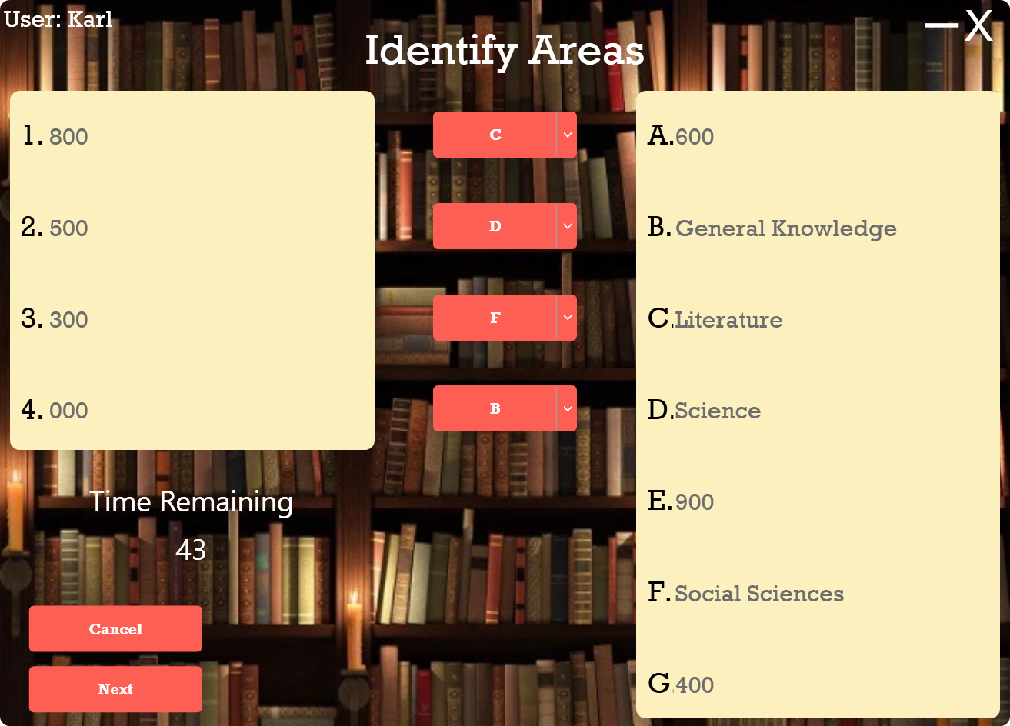**Identify Areas**

The user may select the “Start” button, and select all their answers from the dropdown boxes next to each question.

For example, the image provided shows the answers to the provided training session.

This training system also has gamification techniques implemented, in the form of a countdown timer, and logging of scores, much like the “Replace Books” exercise.

Once columns have been matched, by selecting an answer for each question from the dropdown boxes, the user can select “Next” to navigate the user to the confirmation page.

Input validation has been implemented on this page, so all inputs have to be valid.

Shown next is the confirmation page.

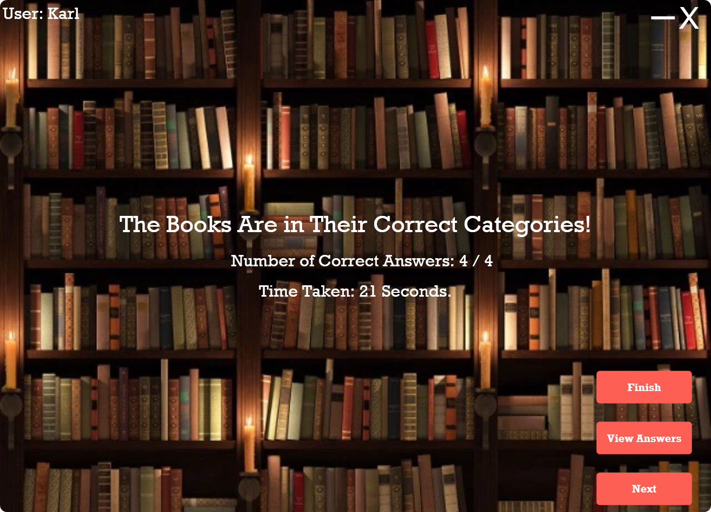**Confirmation Page**

Once the user has selected “Next” or the timer has run out, the user will be navigated to a confirmation page, where it will be determined if all answers were correctly answered (the columns were matched correctly).

The user will be presented with the number of correct answers, and time taken to complete the test.

The user can navigate back to the main menu by pressing the “Finish” button, view the model answer by pressing “View Answers”, or press “Next” for another “Identifying Areas” training session.

The model answer page is provided on the following page, where the answers for all questions are provided.

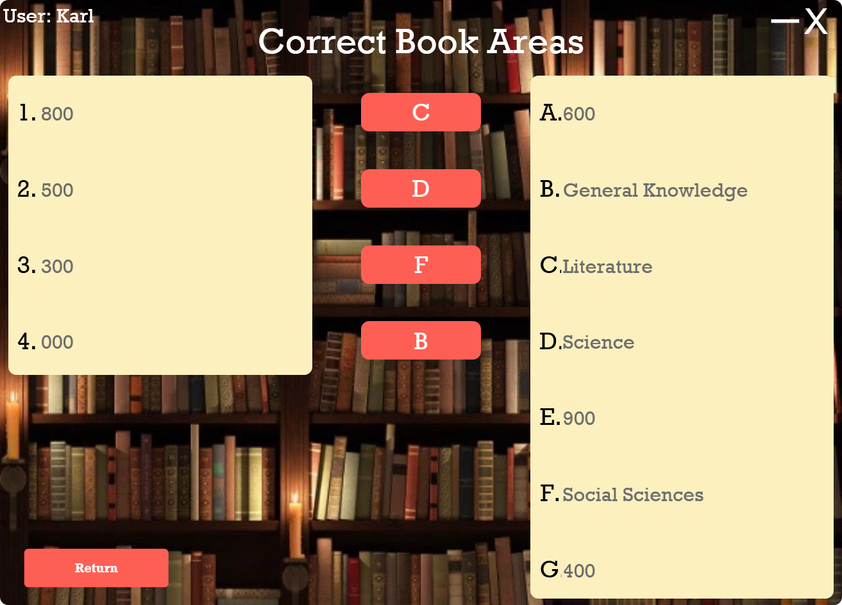**Correct Book Areas**

If the user presses the “View Answers” button, a page with the model answer will be provided, so that the students and librarians can learn from the system, and not only test their knowledge of the Dewey decimal system.

If the user presses the “Return” button, they will be brought back to the confirmation page, where they can continue with another identifying areas session, or finish the game.

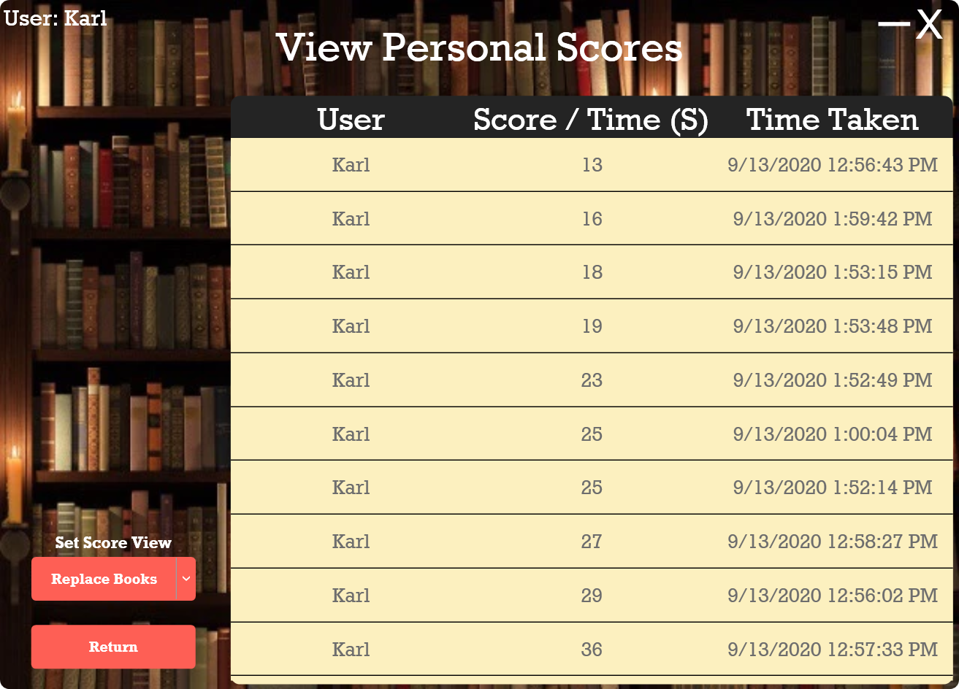**View All Scores – Replacing Books**

If the user presses the “View All Scores”, a page with all their personal scores will be displayed for both the “Replace Books”, and “Identify Areas” training sessions.

If the user wishes to view scores for the “Identifying Areas” sessions, they can select that option from the dropdown just above the “Return” button, and all their scores for that game / training type will be displayed.

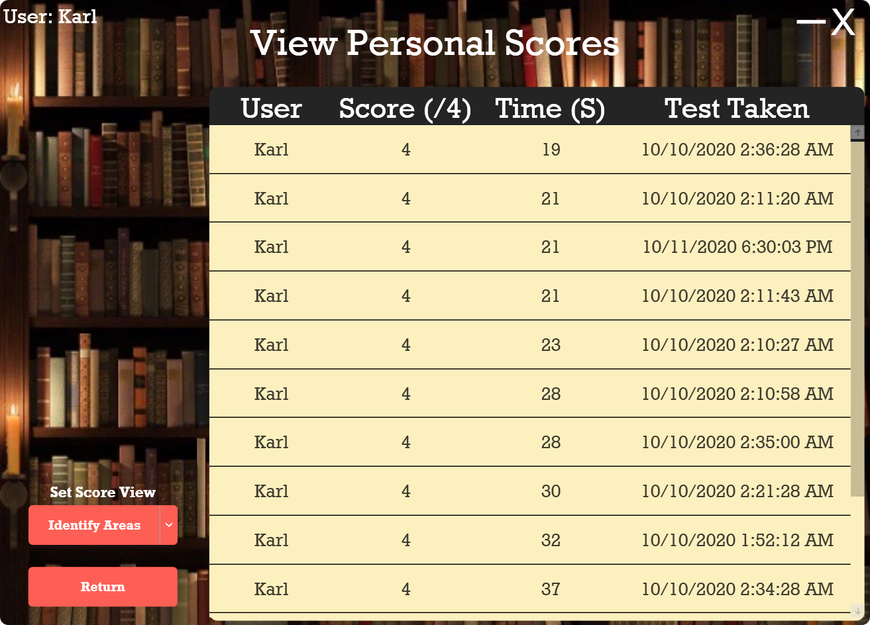**View All Scores – Identifying Areas**

If the user selects the dropdown box from above the “Return” button, they are presented with all “game” types, including “Replace Books”, “Identify Areas”, and “Find Call Numbers”.

This can be set on the main menu page as well, where the top ten scores are shown.

The following image shows the scores for “Identify Areas” training sessions for the logged in user.

This includes the username, score, time taken to complete the test, and the time that the test was taken.

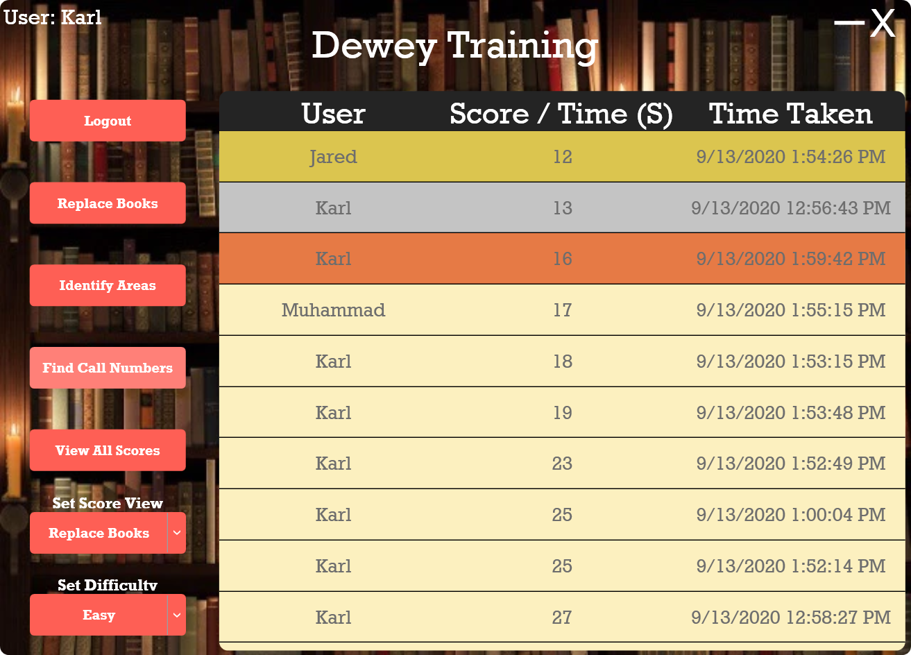**Set Game Difficulty**

If the user wishes to change the game difficulty, by reducing the total time that is allowed for each training session, they can set the difficulty – the lowest dropdown element on the provided screenshot.

This will set the times of the counter to 60 seconds for Easy, 40 seconds for Medium, and 30 seconds for Hard difficulties.

# Database Entities

The User model defines what is saved for each user in the system. This includes the user id, username, and password.

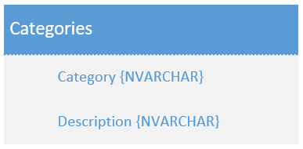The Categories model defines what information is stored for each Dewey Decimal category (for Task 2).

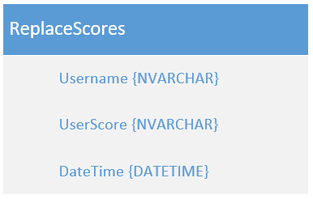

The ReplaceScores model defines what is saved for each replace books test score entry in the database, which includes the username of the user who achieved the score, the score value, and the date and time that the entry was inserted into the database.

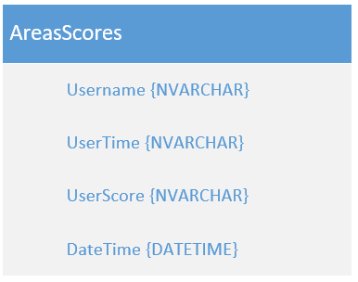The AreasScores model defines what is saved for each identifying areas test score entry in the database, which includes the username of the user who achieved the score, the time it took to complete the test, the score value, and the date and time that the entry was inserted into the database.

# Use Case Diagram

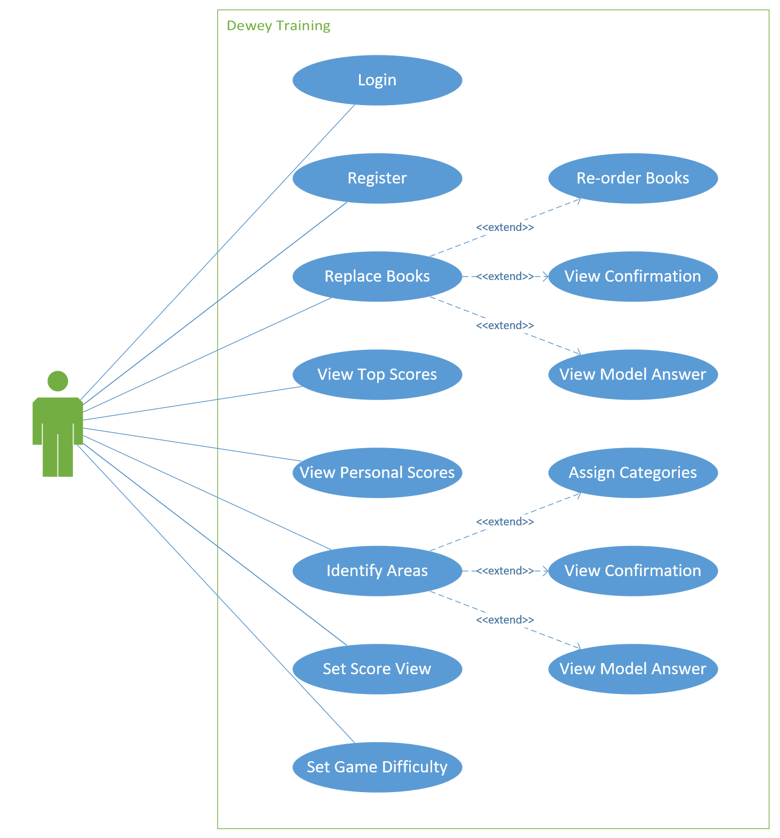

# Conclusion

In conclusion, this documentation has provided extensive development information in order to detail how and why the Dewey Decimal desktop application was developed in the way that it was. It described each function of each page within the “Help File” section, and provided user interface design information within the “Screenshots” section. A “Readme” section was also included in the document to provide information about the development environment, instructions on how the desktop application should be run, and other such critical information to get the application running on the user’s PC.  
Additional information such as all the database entities was provided, which detailed how and where data was stored by the application.  
In addition to the above, a use case diagram was included, which showed core functionality of the desktop application from the user’s perspective.

During the course of this project, we have learnt how to develop advanced C# desktop applications in the .Net Core 3.1 Framework. We also learnt how to use a Data Access Layer – DAL to access information from a local MDF file, and later on this will be hosted online. In addition to this, we have learnt how to use advanced data structures, including Doubly Linked lists, Dictionaries, Key Value lists, and Observable Collections in addition to other datatypes.

Once we receive feedback for this task, we will be in a position to complete the POE task, which builds on the functionality of this application.

# References

Jaboss. (n.d.). *Library Icon*. Retrieved from Cleanpng: https://www.cleanpng.com/png-library-computer-icons-librarian-reference-work-cl-5637031/

Laja, P. (n.d.). *How to Use Gamification for Better Business Results*. Retrieved from Neilpatel: https://neilpatel.com/blog/gamification-for-better-results/

Quicksprout. (2016, 07 15). *How to Easily Add Gamification Techniques to Your Content*. Retrieved from Quicksprout: https://www.quicksprout.com/how-to-easily-add-gamification-techniques-to-your-content/

The Independent Institute of Education. (2020). *PROG7312 POE Question Paper.* Sandton: The Independent Institute of Education.

Wolfie. (2019, 01 28). *Library Background Image by Wolfie*. Retrieved from Picsart: https://picsart.com/i/286394316039201